ASSIGNMENT-8.1
NAME:M.NITHIN CHANDRA
HALL NO:2403A52141
BATCH NO:06
TASK-1:
write a python code to print atleast three assert test cases for is strong_password and implement the validator function tht has password with atleast 8 characters includes upper case and lower case and special character and not contain any spaces.
CODE & OUTPUT:
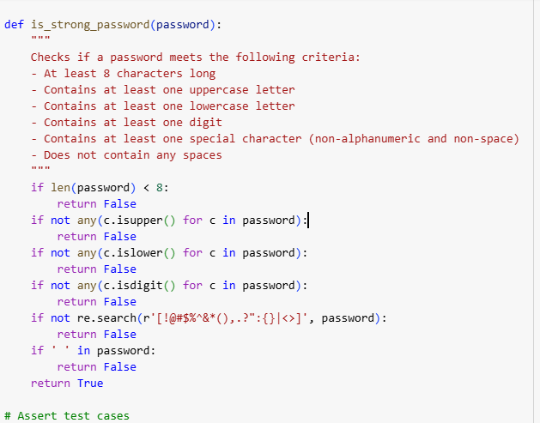
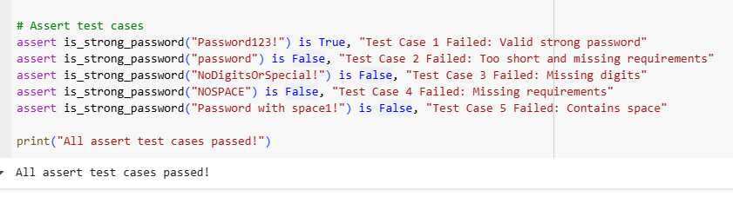
EXPLANATION:
- Function Definition: Defines a function is_strong_password to validate passwords.
- Length Check: Ensures the password is at least 8 characters long.
- Uppercase Check: Requires at least one uppercase letter.
- Lowercase Check: Requires at least one lowercase letter.
- Digit Check: Requires at least one digit.
- Special Character Check: Requires at least one special character (e.g., !, @, #).
- Space Check: Prohibits spaces within the password.
- Return Value: Returns True if all criteria are met, False otherwise.
- Test Cases: Includes examples to demonstrate function usage and verify its correctness.

TASK-2:
Write a python code to classification of numbers with loops create at least three test cases for classify_number (n) function implement using loops to classify the nymbers as positive ,negative or zero handle invalis inputs like strings and none.
CODE & OUTPUT:
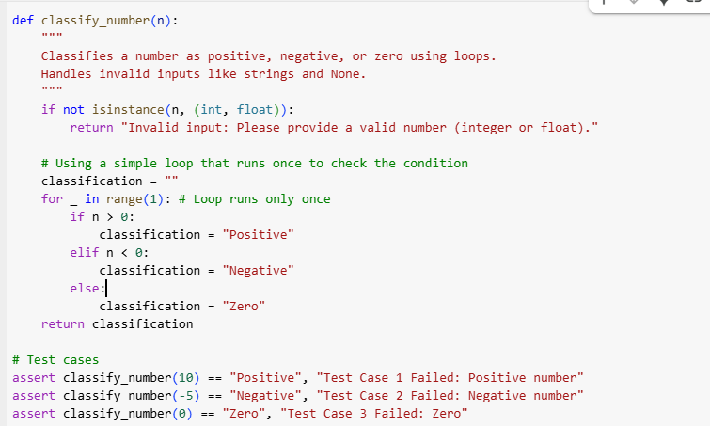
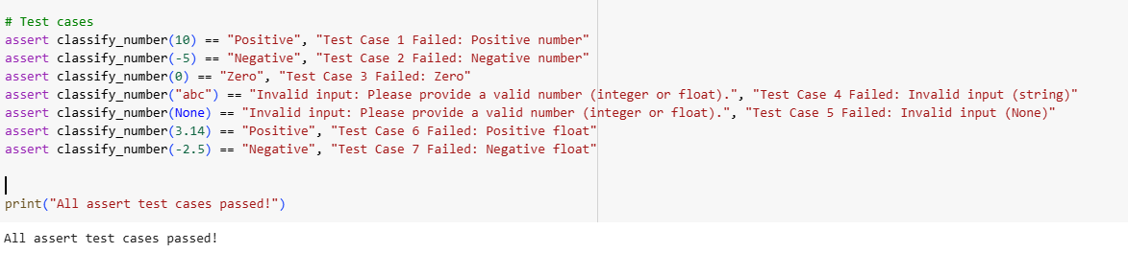
EXPLANATION:
- Function Purpose: Classifies a given input as positive, negative, or zero.
- Input Validation: First, it checks if the input is a valid number (integer or float).
- Invalid Input Handling: If the input is not a number (like a string or None), it returns an "Invalid input" message.
- Loop Usage: It uses a simple loop that runs only once to perform the classification checks.
- Positive Check: Inside the loop, it checks if the number is greater than zero.
- Negative Check: If not positive, it checks if the number is less than zero.
- Zero Check: If neither positive nor negative, it classifies the number as zero.
- Classification Result: Stores the classification ("Positive", "Negative", or "Zero") in a variable.
- Return Value: Returns the determined classification or the invalid input message.
- Test Cases: Includes example tests to verify the function's behavior with different inputs.
TASK-3:
Write a python code for angram checker with string analysis to generate at least three assert test cases for is_anagram (str1,str2) and implement the function. ignorecase, spaces and punctuation and handle edge cases like empty strings and identical words.
CODE & OUTPUT:
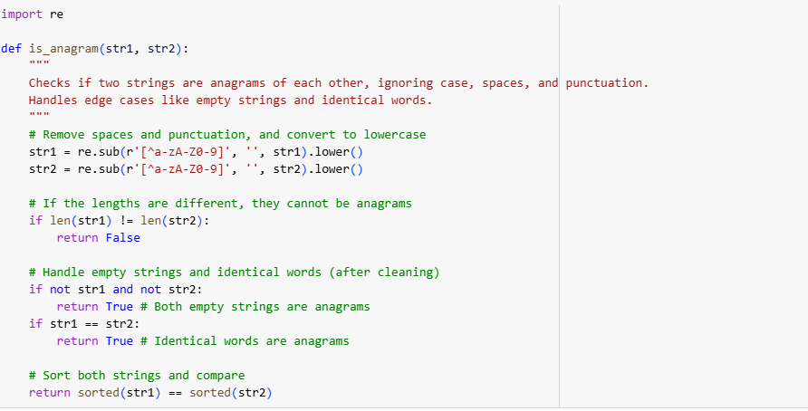
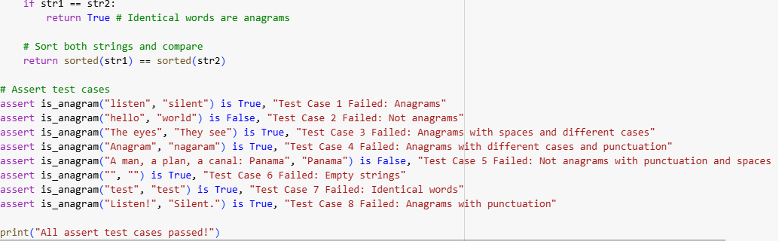
EXPLANATION:
- Function Purpose: Checks if two input strings are anagrams of each other.
- Cleaning Strings: Removes spaces and punctuation from both strings and converts them to lowercase.
- Length Check: Compares the lengths of the cleaned strings; if they differ, they can't be anagrams.
- Edge Case: Empty Strings: Handles the case where both input strings are empty (they are considered anagrams).
- Edge Case: Identical Words: Handles the case where the cleaned strings are identical (they are considered anagrams).
- Sorting: Sorts the characters of both cleaned strings alphabetically.
- Comparison: Compares the sorted strings.
- Anagram Determination: If the sorted strings are identical, the original strings are anagrams.
- Return Value: Returns True if the strings are anagrams, False otherwise.
- Test Cases: Includes various examples to test different scenarios, including edge cases and strings with spaces and punctuation.

TASK-4:
Write a python code of inventory class to generate at least three assert based tests for an ineventory class with stock management. and add_item(name, quantity), remove_item(name,quantity),get_stock(name).
CODE & OUTPUT:
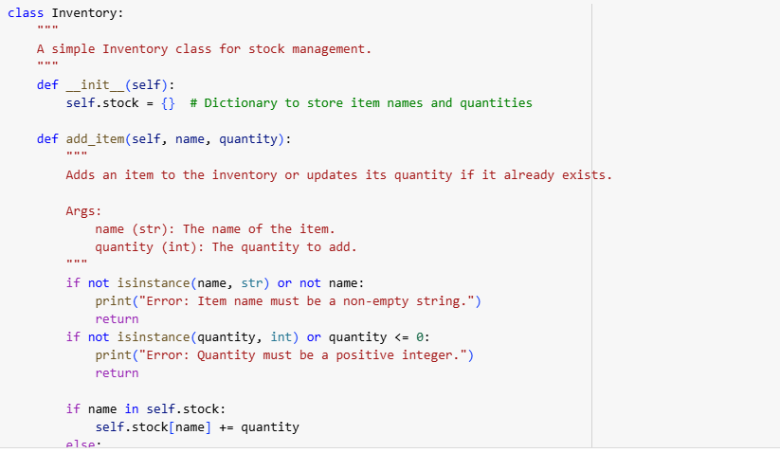
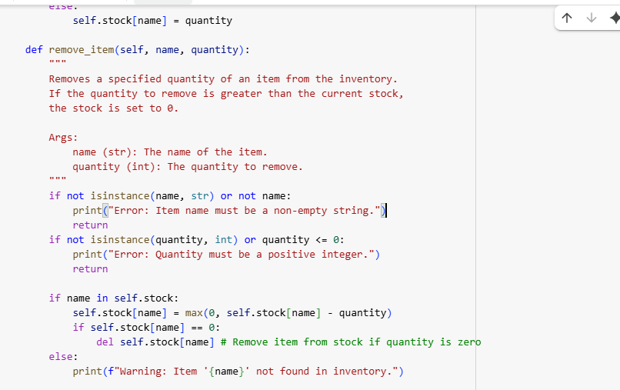
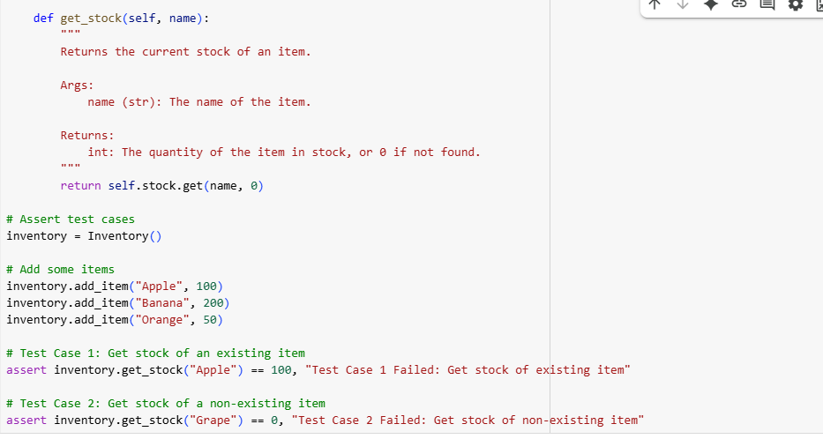
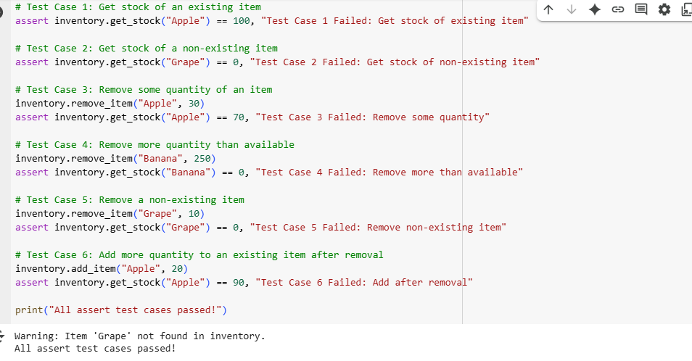
EXPLANATION:
- Purpose: Manages the stock of items in an inventory.
- __init__: Initializes an empty dictionary stock to store items and their quantities.
- add_item: Adds a specified quantity of an item, handling new items or updating existing ones, with input validation.
- remove_item: Removes a specified quantity of an item, ensuring stock doesn't go below zero and removing the item if stock reaches zero, with input validation.
- get_stock: Returns the current quantity of a specific item, or 0 if the item is not found.

TASK-5:
Write a python code of date validationn and formatting to geenerate atleast 3 assert test cases for validate_and_format_date(date_str) to check and convert dates. it should contain"MM/DD/YYYY" format ,handling invalid dates ,and converting valid dates to "YYYY-MM-DD".
CODE&OUTPUT:
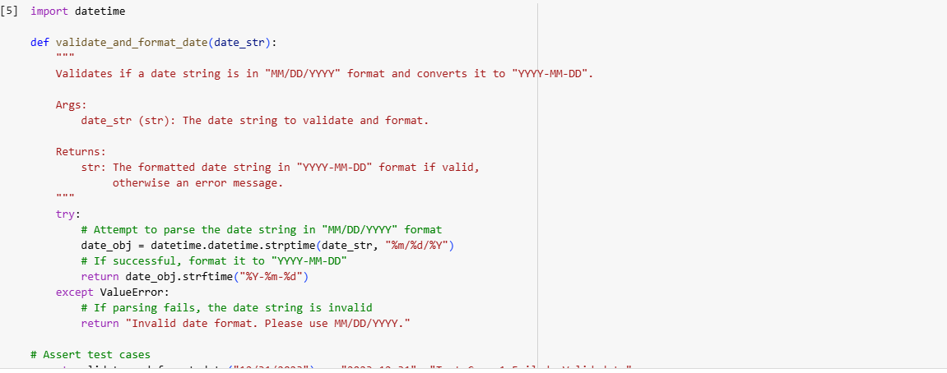
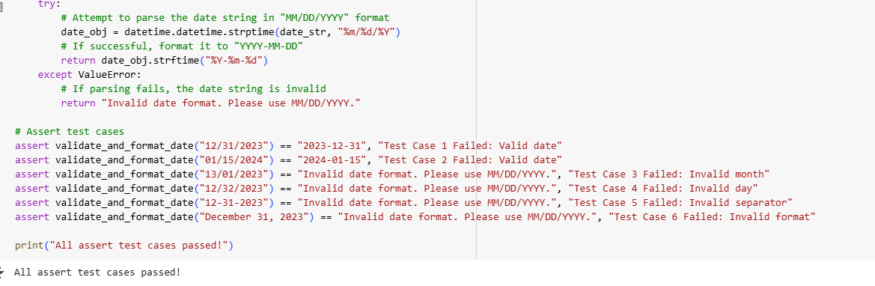
EXPLANATION:
- Function Goal: To check if a date string is in "MM/DD/YYYY" format and convert it.
- Input: Takes a single string date_str as input.
- Validation Method: Uses a try-except block to attempt parsing the date string.
- Parsing Format: It specifically tries to parse the string using the "%m/%d/%Y" format.
- Valid Date Handling: If parsing is successful (the date is valid and in the correct format), it proceeds.
- Formatting: It then formats the valid date object into the "YYYY-MM-DD" format using strftime.
- Return for Valid Date: Returns the newly formatted date string.
- Invalid Date Handling: If parsing fails (due to incorrect format, invalid month/day, etc.), a ValueError is raised.
- Return for Invalid Date: In the except block, it catches the ValueError and returns an "Invalid date format" error message.
- Usage: The function provides a way to standardize date formats and identify invalid date inputs.

